URL | Screenshot for 360 Vacation center
http://thefamilywithoutborders.com/accomodation-best-ways-to-stay-over-on-a-trip-2016-09-29/comment-page-1/#comment-54070 | 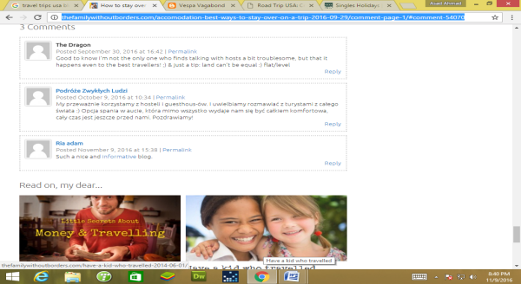
http://www.wanderingearl.com/please-dont-be-afraid-to-travel-on-your-own/comment-page-6/#comment-7937677 | 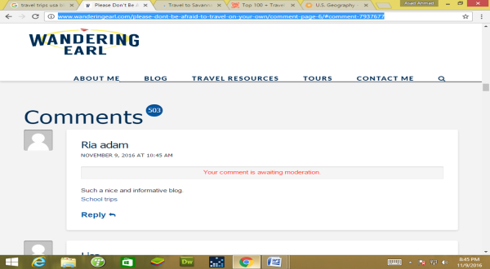
https://www.mappingmegan.com/travel-savannah/#comment-1035375 | 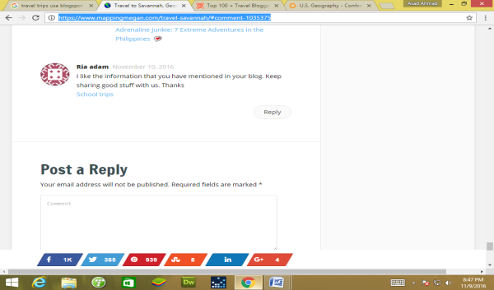
http://wanderingtrader.com/travel-blog/top-things-myanmar-tourist-attractions/#comment-9521 | 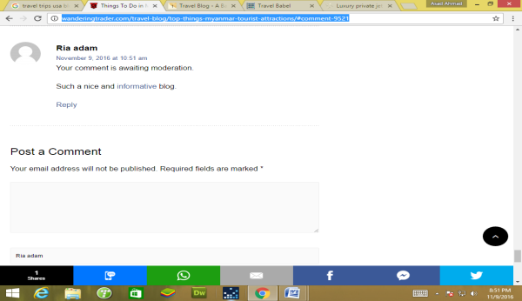
http://snowmads.blog/myths-versus-reality-of-driving-your-rv-to-alaska/#comment-16237 | 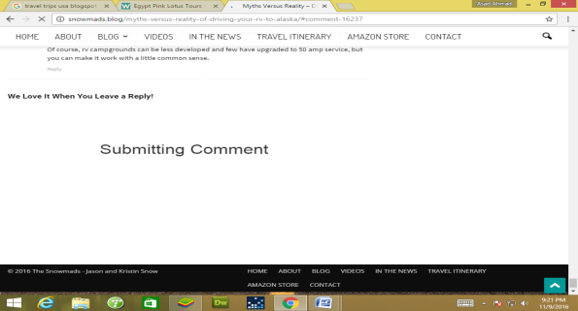
https://www.cheapair.com/blog/destinations/fleeing-the-country-heres-what-you-need-to-know-about-canada/#comment-706296 | 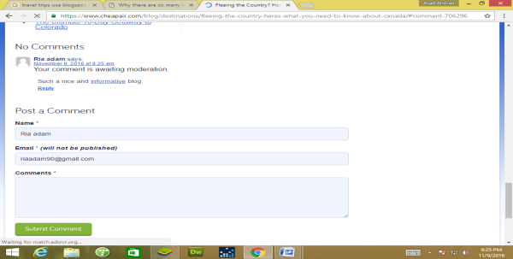
http://www.urbanadventures.com/blog/why-many-temples-bali.html#comment-292 | 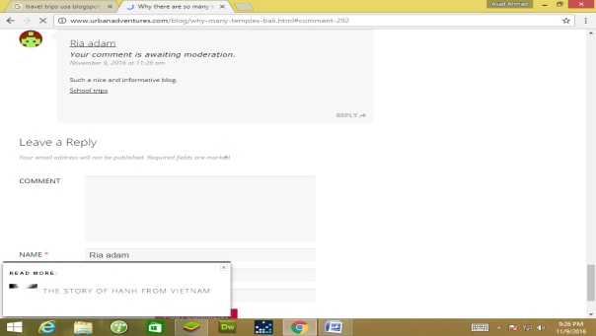
https://irene-travelogue.com/2016/11/06/best-singapore-bloggers-of-2016/#comment-7277 | 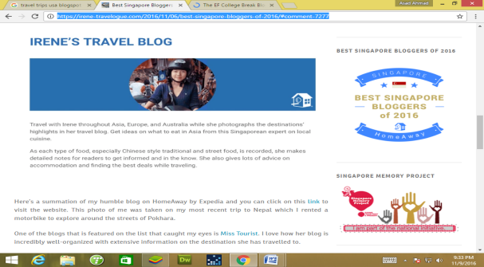
http://www.autoeurope.com/blog/weekly-list/30-fantastic-quotes-about-travel#comment-15988 | 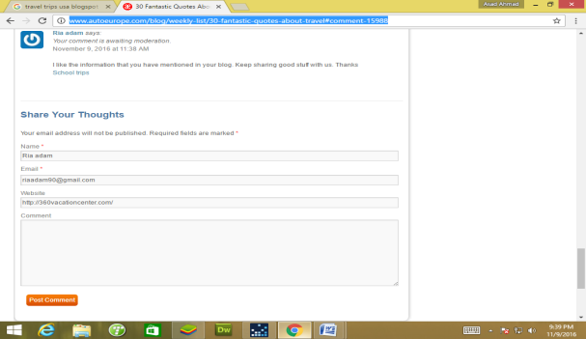
http://www.theshelf.com/blogger-roundups/2015/6/3/12-fashion-bloggers-with-chic-travel-style | 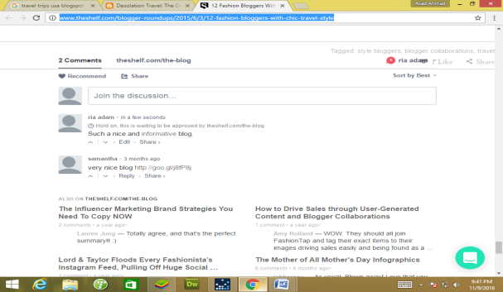
https://desolationtravel.blogspot.com/2015/10/the-democratic-republic-of-congo.html?showComment=1478709776054#c5355973260428699416 | 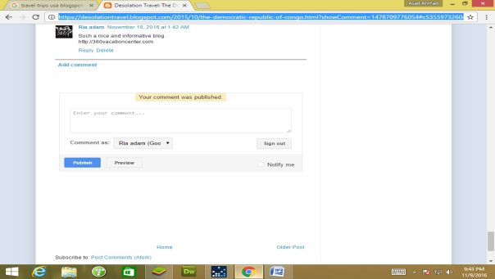
http://blog.sandiego.org/2016/11/top-things-to-do-san-diego-172/#comment-49272
http://thrillingtravel.in/2016/10/tata-hexa-new-companion-road-trips.html#comment-6854 | 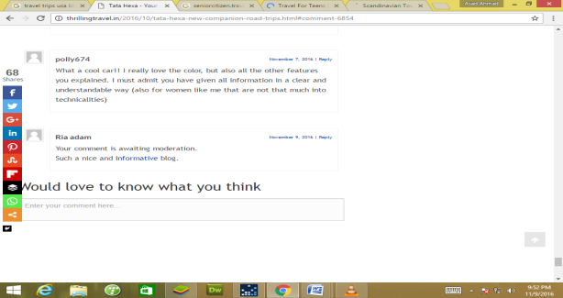
https://cornandokra.blogspot.com/2011/01/ruidoso-new-mexico-and-ski-apache.html?showComment=1478710611937#c3240287091447523404 | 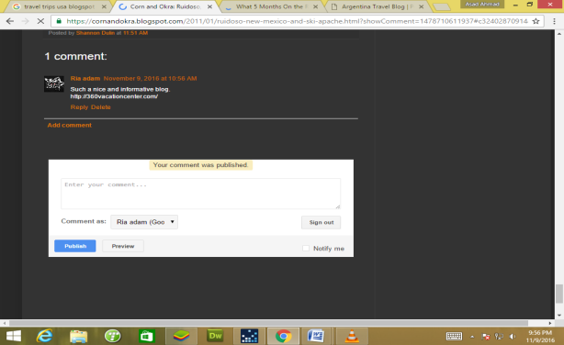
http://www.curiositytravels.org/5-months-road-later-second-season-tour-leading-whats-new/#comment-104752 | 